**Joining Our Google Classroom**

1. Open Google (I recommend using Google Chrome)
2. In the top right-hand corner, click **Sign In**

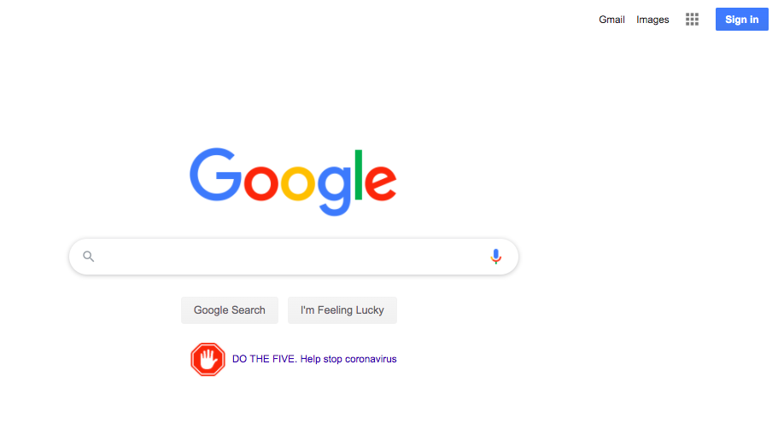

* 1. If you do not see the **Sign In** option, you will need to click on the grid in the upper right-hand corner and select the **Account option**

1. Sign in using your district account
   1. Username: Last two numbers of your lunch pin, first initial, first three letters of your last name followed by @indians.k12.pa.us
      1. Example: [37bsmi@indians.k12.pa.us](mailto:37bsmi@indians.k12.pa.us)
   2. Password: Your 6-digit lunch pin
      1. Example: 124356

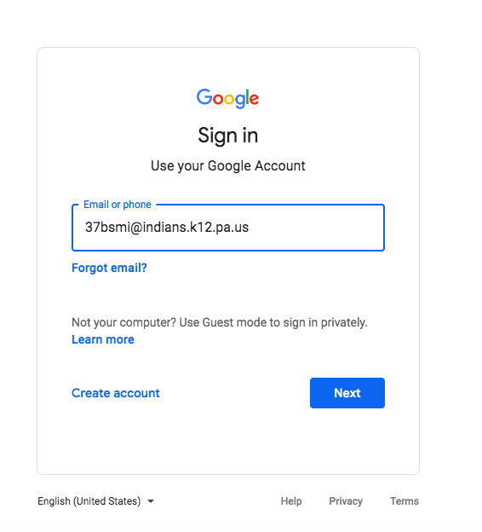

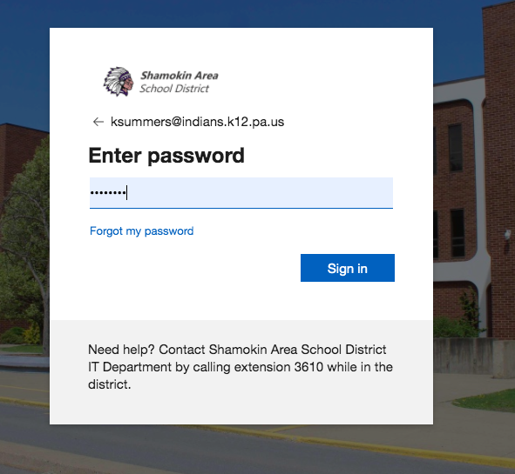

1. Click Sign In
2. You will be directed back to the Google browser, but in the top right-hand corner, you will see your first initial.

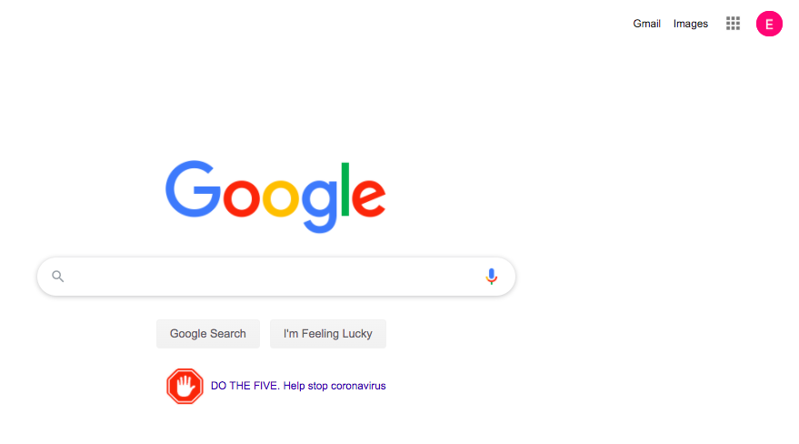

1. Click on the grid next to your initial and click the Google Classroom icon.

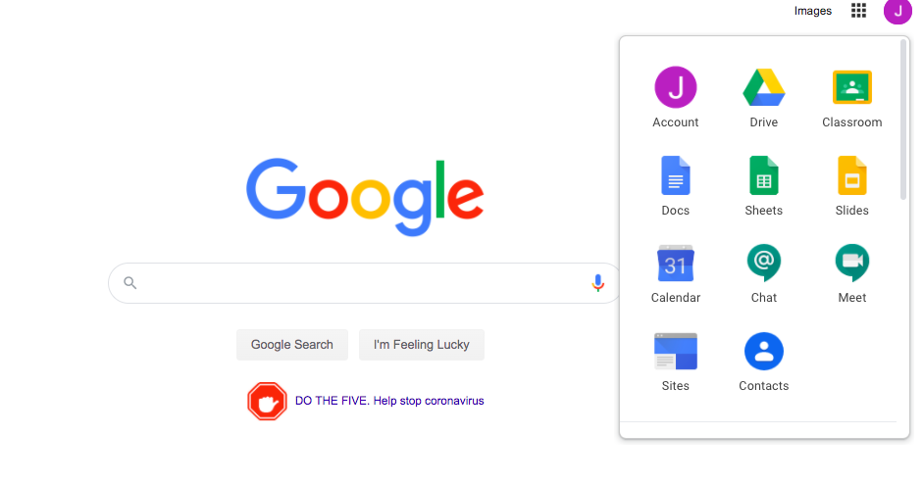

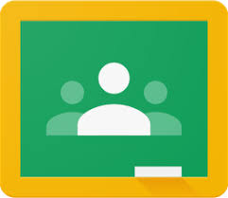(this is the Classroom icon)

1. You will be directed to the Google Classroom suite.
2. Select: I’M A STUDENT
3. Click the JOIN button to join my classroom.

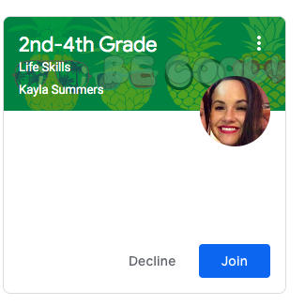

1. You will see the assignments on the home page.

